Sweet quotations of Sadguru
Sri Nannagaru
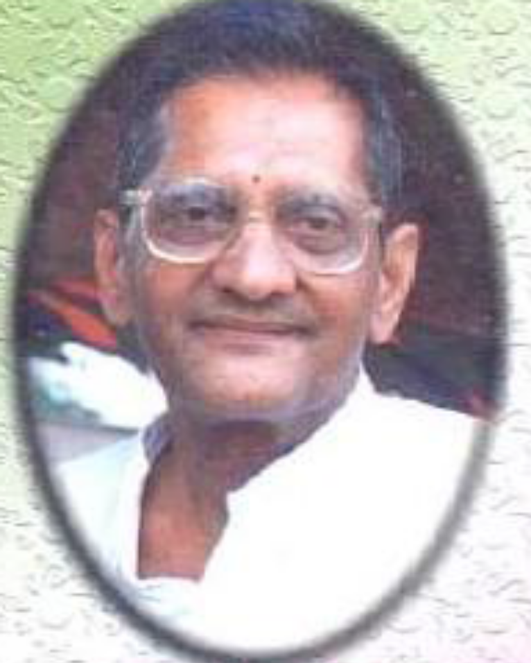

The Translated version of the Telugu book ‘Madhura Vakyamulu’

Foreword

Self Knowledge is experiential. Only they are eligible to be called as Sadguru who possess Self Knowledge. Sadguru Sri Nannagaru belongs to such a category. The words that come out of such people also represent Grace. This book is a collection of sweet utterances written by Sadguru Sri Nannagaru in his own hand writing since last 20 plus years upon the request of devotees. Hope you will all read this, contemplate upon it, reform your mind and make effort from your end to attain Self Knowledge.
-Sri Ramana Kshetram, Jinnuru

In order to to experience the Self, make an attempt from today itself.



Purity (of mind) is the foundation of spiritual life.




On meditating upon Self, the sorrow & sin are eradicated; the Self Knowledge & Bliss are bestowed.



Earn the sattvic quality and get rid of Rajasic and Tamasic qualities.

Try to earn sattvic quality and try to get rid of Rajasic and Tamasic qualities.

Education and penance resemble our two eyes. A spiritual aspirant must carefully protect both of his eyes.



The path of devotion is the smoothest (as well as sweetest) path. One can very easily get rid of their impurities of mind by adopting this path.




Learn Forbearance.



If it is practiced to place the mind upon God, the concentration and purity will increase.


Both the Concentration of mind and Purity of mind are necessary for attaining Self Knowledge.


We must learn to divert the mind away from mean and petty things.



Habituate Sattvic thinking faculty.



If you lead a pure life, the ignorance gets annihilated.


We must tread the path of righteousness. All the types of Knowledge merge within Self Knowledge.


When you learn forbearance, God bestows you with everything.


Rather than adoring a Jnani, if we try to make effort to understand a Jnani, the Self can be brought into experience.


If you sacrifice the ego (aham vritti) contained in your nature (pravritti), you will attain surrender (prapatti).


One who forgets God is left only with the ego.



We must ensure that the thought within the mind, the words of the mouth and the work done with the hands are always pure.


Humility is the only medicine to annihilate the ego.



Desireless work begets Self Knowledge.


A Jnani does not exist as ‘i’ but exists as ‘I’ (Self).

Equanimity is the wealth of Life.


We must learn to spend our life devotedly (shradda), tolerantly (orpu) and skilfully (nerpu).


Pride or arrogance becomes an obstacle in the spiritual progress.



The Mind is not apart from Self.


When the thoughts pertaining to the body bound ‘i’ ( ie., ego) are annihilated, what is left out is only the Source resulting in permanent Bliss.

Agitation (of mind) is of no use.

Thinking is very important.


The Truth within Heart is revealed if mind control and sense control is achieved.



Search and find the source of the first thought ‘i’, the Joy is known.


The Love for God reduces the attraction towards sensory objects.



Dispassion arising out of discrimination is needed.



One can do good to others through thought, word and deed.

Tolerance is necessary.



Desire and Anger are the greatest obstacles in attaining Self Knowledge.

By regulating the word, mind and body the Holy state is attained.



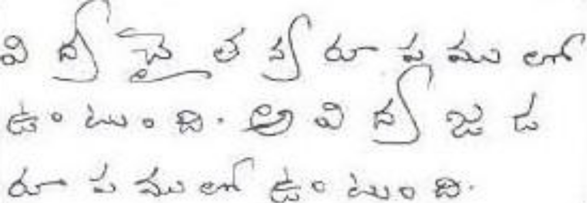

Knowledge exists in the form of Energy. Ignorance exists in the form of matter.


Your Heart becomes still if you habituate culture in life.



For the mind, ego is like the Mother.


Learn to work without the burden of ego.

By constantly contemplating upon the Holy Hill of Arunachala, the mind merges into the Heart.



Our goodness increases if we learn to look at the goodness in others.


For the suppressed mind, the Self is revealed.



When bad qualities are kept away, God enters our Heart and begins to work.



Ensuring that the ego doesnot raise its head amounts to spiritual practice (sadhana).



Sorrow exists in the form of ego.



One who constantly contemplates upon God attains Supreme Peace and one-pointedness of mind.



Ego is the cause of all the problems.



One can undoubtedly attain God through devotion.


Bhagavan’s name and Bhagavan’s form is sufficient for you. Bhagavan’s preaching bestows you with Supreme Peace.



I take refuge in Lord Sri Rama



Om Sreem Ram Ramaya Namaha



Om Skandaya Namaha



Arunachala Shiva

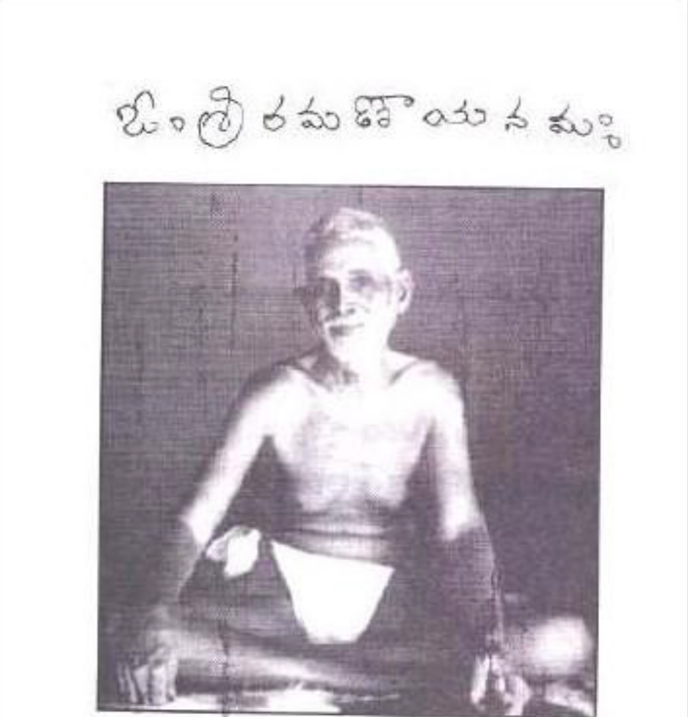
Salutations to Sri Ramana

